|  |  |
| --- | --- |
| **Practicum Case** |  |
| COMP6140  Data Mining |
| **Computer Science** | **O191-COMP6140-NP01-02** |
| ***Valid on*** *Even Semester Year 2019/2020* | **Revision 00** |

## Soal

*Case*

**Bluejack University**

A currently running poll is being held by Bluejack University to predict the current student satisfaction of the provided education. They are given 10 questions, where questions 1 – 5 are ***Likert Scale Questions*** (questions which answers are chosen from a range), and questions 6 – 10 are ***Multiple Choice Questions*** of ***TRUE*** and ***FALSE***.

To support the data analysis, you are asked to visualize the poll data of the students into various charts from the documents provided. The documents given consist of the participants’ data (***Participant.csv***), the questionnaire result (***Result.csv***), and list of the questions (***Question.csv***).

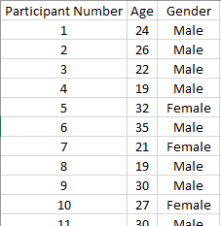

Figure 1. Participant Data

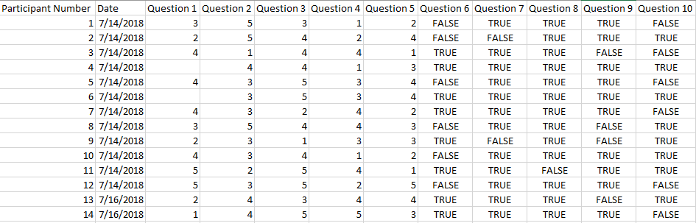

Figure 2. Result Data

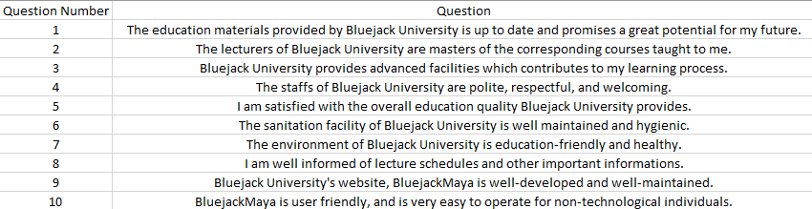

Figure 3. Question Data

However, a misinterpretation of the questionnaire filling guidelines has caused some of the answers for the first question to be **invalid** and **omitted** from the document. Do the following visualizations, considering that the data included must only be **valid data**.

1. Visualize a **pie** **chart** with its legend, illustrating the result of the **second question**.

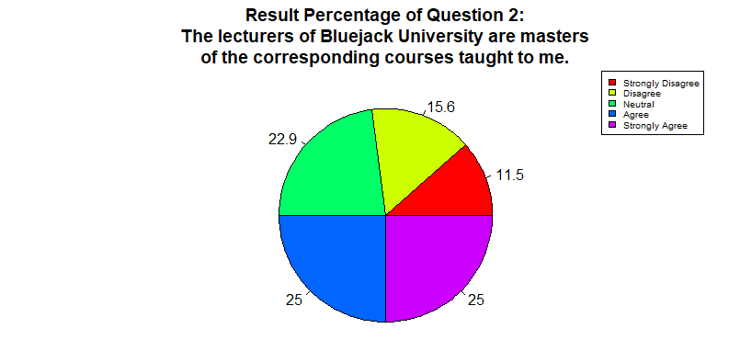

Figure 4. Answer 1

Visualize a **pie** **chart** with its legend, illustrating the result of the **sixth question** for **female participants**.

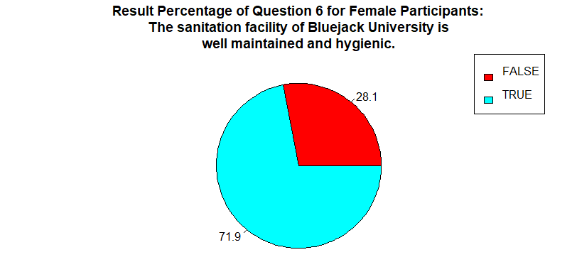

Figure 5. Answer 2

1. Visualize a **group** **bar chart** with its legend, illustrating the result of the **first question** and the **gender** of the participant.

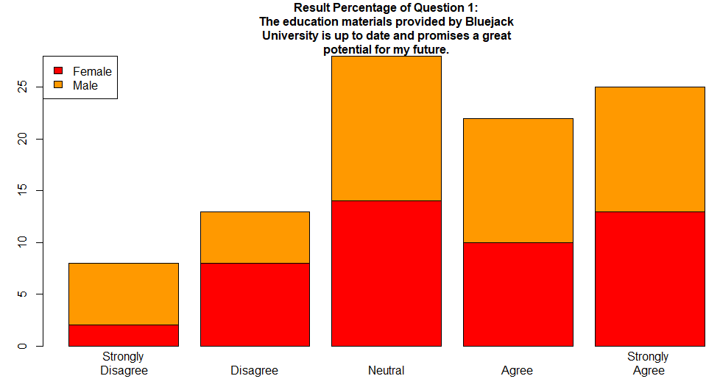

Figure 6. Answer 3

1. Visualize a **boxplot**, illustrating the relationship between the result of the **first question** and the **gender** of the participant.

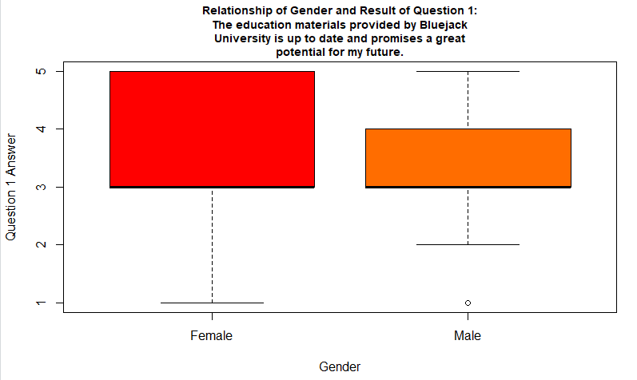

Figure 7. Answer 4

1. Visualize a **histogram**, illustrating the result of the **fourth question**.

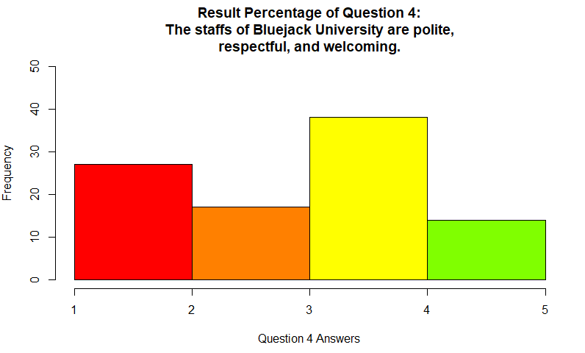

Figure 8. Answer 5

1. Visualize a **stacked bar chart**, illustrating the **results of question 1 to 5**.

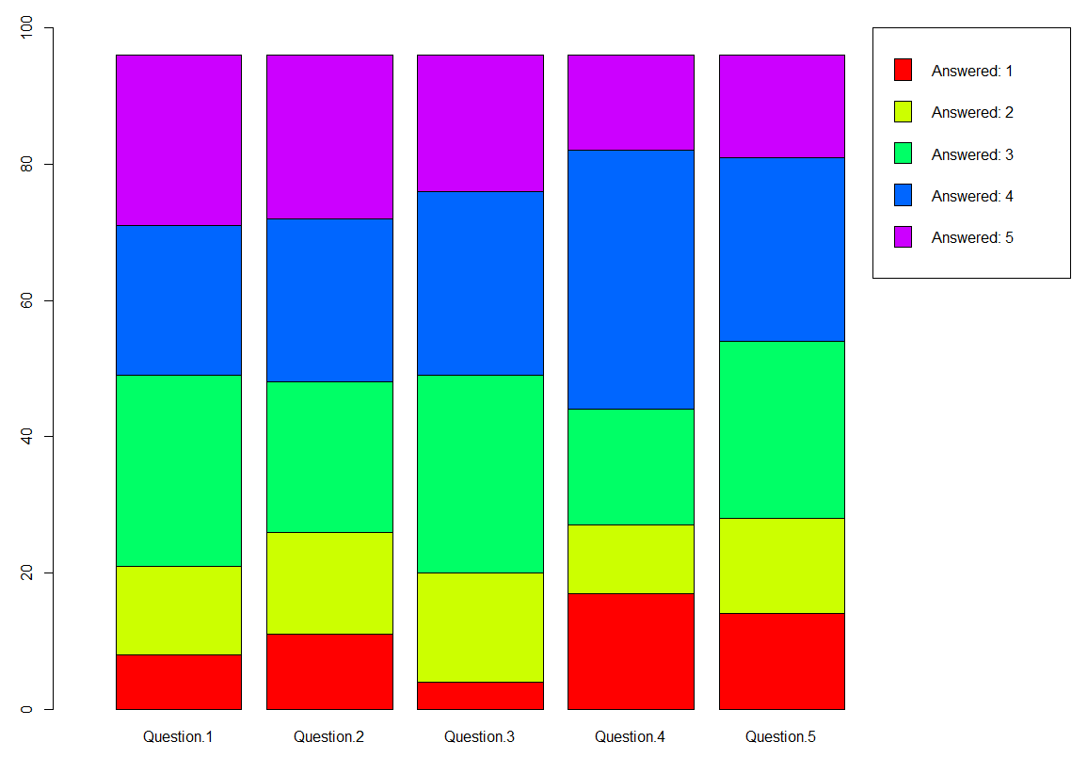

Figure 9. Answer 6

1. Visualize a **dot chart** and a **line chart**, illustrating the **amount of survey participants each day**.

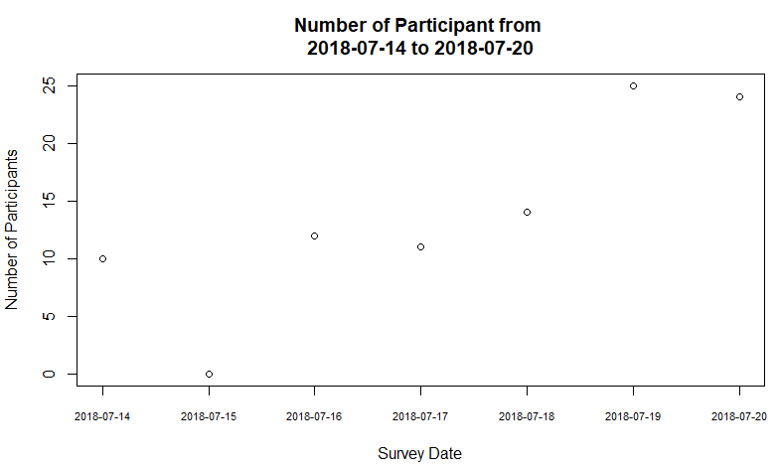

Figure 10. Answer 7 (part 1)

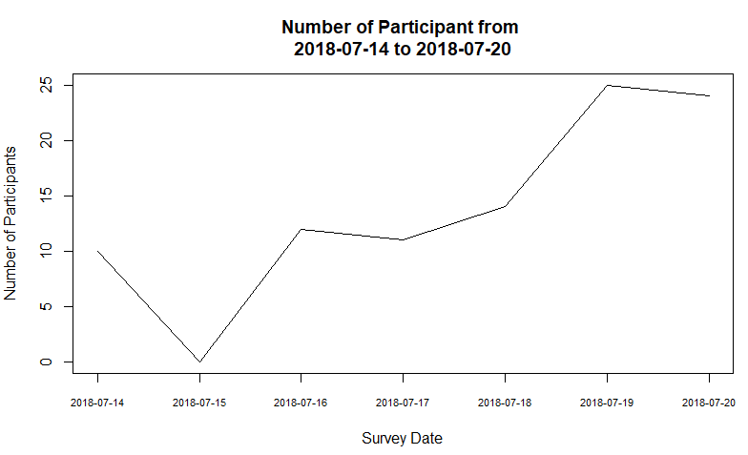

Figure 11. Answer 7 (part 2)

1. Visualize a **dotted line chart**, illustrating the **amount of survey participants each day**, and **save the visualization** as **result.png**.

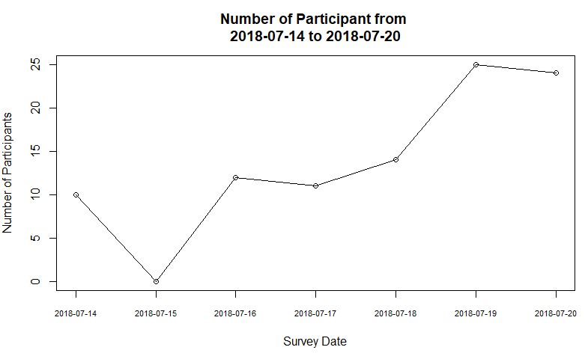

Figure 12. Answer 8